Use mBot with App Inventor V1.9

Makeblock Co., Ltd.

This document is licensed under CC-BY 3.0,
Feel free to use, print, translate, or use it in your own material.

For more information, contact wangyu@makeblock.com

MIT App Inventor is a drag-and-drop block-based editor which can make Android Apps. You can use App Inventor to control mBots through an extension.

What’s new in Version 1.9
- Uses Bluetooth 4.0 (BLE), which simplifies the connecting experience. Now you may connect your mBot with even only one button.
- Added support for 9g mini servo
- Now sensor values are read through events, easier for programming.

Add the mBot Extension to MIT App Inventor
MIT App Inventor is a drag-and-drop block-based editor which can make Android Apps. You can use App Inventor to control mBots through an extension.

Step 1. Go to MIT App Inventor’s website; create or open a project.

Step 2. In the Extension category of the Palette, click Import Extension. And switch to the URL tab in the opening dialog box.

Step 3. Paste the following link to the text box, and click Import.
http://appinventor.makeblock.com/MBot_v1.9.aix
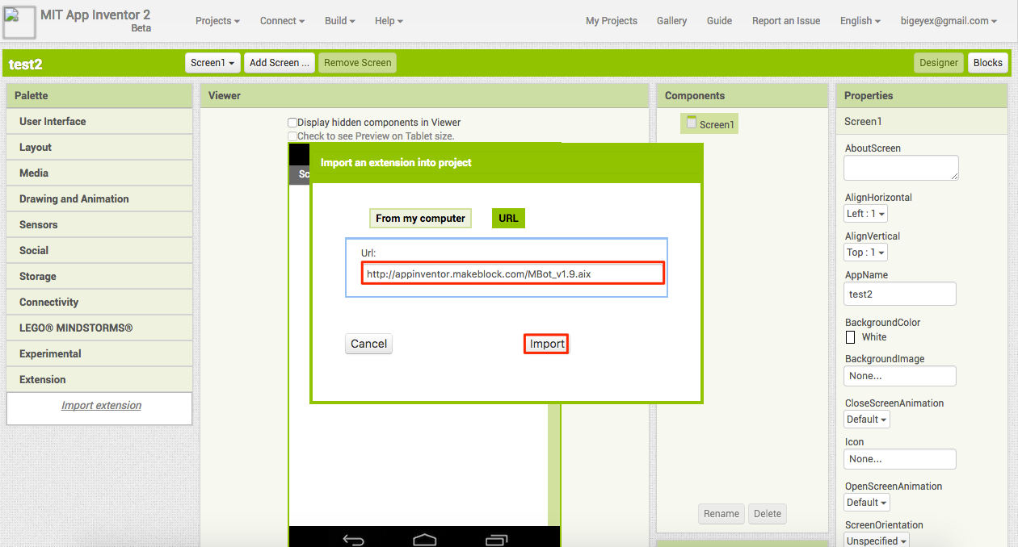

Step 4. Click OK in the Rename extension dialog.

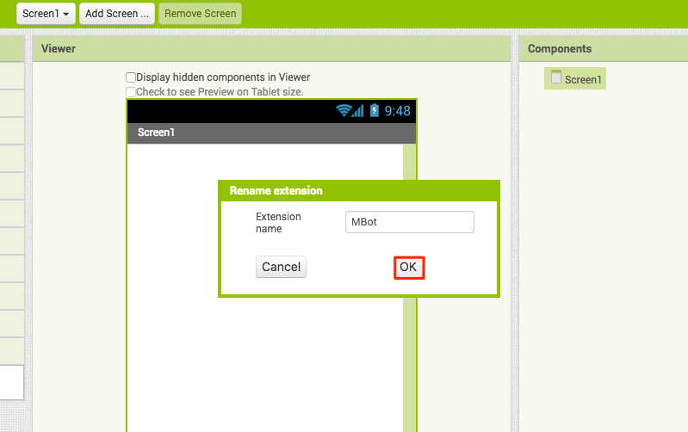

Step 5. Now you can see mBot in the Extension category. Drag it onto your phone screen.

Connect to a mBot with your Android App
Whenever you want to connect the robot, use the Connect to robot block.

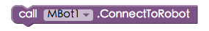

Your phone will start searching for the nearest robot and connect it if close enough.

Tip:
If you run “Connect to robot” block again, the phone will close the previous connections and try to connect again.

Tip:
If you cannot connect the robot, please check: 1. Whether Bluetooth on the phone is enabled; 2. Whether the robot’s power is on. And of course, your phone needs to support Bluetooth 4.0.

Issue commands to your robot
After the robot is connected, commands regarding to motors, lights, sound and servos become available.

Here is an example of telling the robot to move forward when the button is clicked:
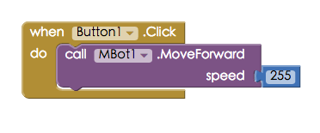

Read Sensor Values
In version 1.9, you need to “open” a sensor first, then use the sensor values in “received sensor value” blocks.

For example, the following blocks “open” the ultrasonic sensor when the mBot is connected:
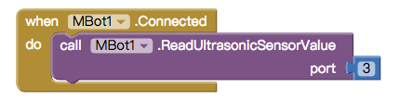

Then you can use the sensor value in the “when mBot receive ultrasonic value” block. This is an example of obstacle avoidance:
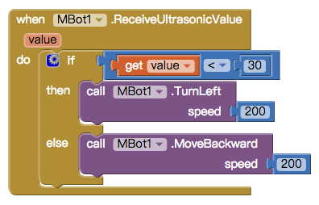

List of Blocks
Here is a list of blocks released in this version:

Connection related Blocks
 | Connect the nearest robot
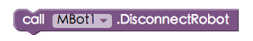 | Disconnect the connected robot
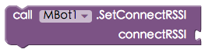 | (Advanced) set the signal strength needed to connect the robot. Suggested values are -60~-30
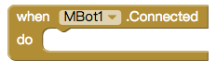 | Run when the robot is connected. Good place to open some sensors.

Motor related Blocks
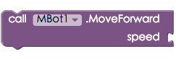 | Tell the robot to move forward
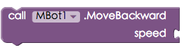 | Tell the robot to move backward
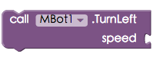 | Tell the robot to turn left
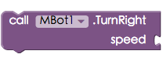 | Tell the robot to turn right
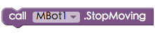 | Tell the robot to stop moving
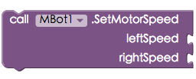 | Set the speed of both motors in one command

Music, color, and mini servo
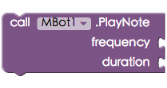 | Play the buzzer for a frequency and duration. Duration is measured in milliseconds.
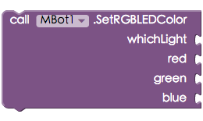 | Lights up the mBot’s top lights with a color described with RGB.  Use numbers for whichLight;  0 – set both lights  1 – set the left light  2 – set the right light
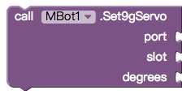 | Turn the mini servo to a certain angle.

Sensors
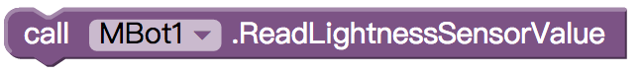 | Start reading the on-board Lightness Sensor value
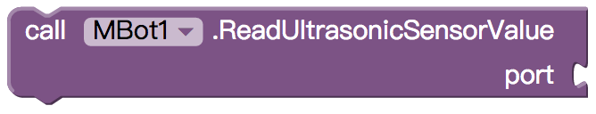 | Start reading the on-board Ultrasonic Sensor value
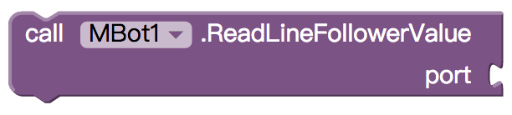 | Start reading the on-board Line Follower Sensor value
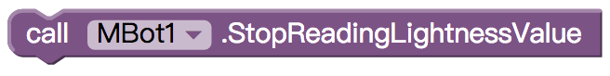 | Stop reading the on-board Lightness Sensor value
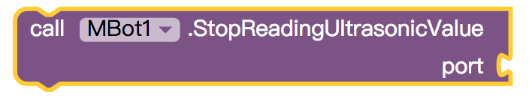 | Stop reading the on-board Ultrasonic Sensor value
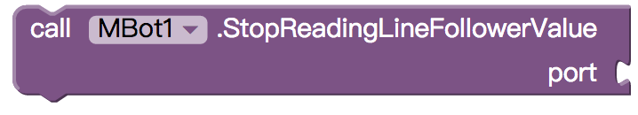 | Stop reading the on-board Line follower sensor value
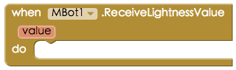 | Run when the Lightness Sensor value updates
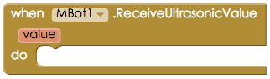 | Run when the Ultrasonic Sensor value updates
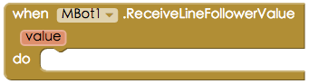 | Run when the Line Follower Sensor value updates

